**Calculating Average Rainfall**

1. Prompt the user to enter the total number of years to include.

2. Initialize `total_rainfall` to 0 and `total_months` to 0 to keep a running total.

3. Use an outer loop to go through each year.

- Within this loop, use an inner loop to go through each of the 12 months.

- For each month, prompt the user to enter the rainfall amount.

- Add this monthly rainfall to `total_rainfall`.

- Increase `total_months` by one to keep track of all months entered.

4. After the loops finish, calculate the average rainfall by dividing `total_rainfall` by `total_months`.

5. Show the results: the total number of months, the total rainfall, and the monthly average rainfall.

**Code:**

# Cal Avg Rainfall

# Get number of years from user

years = int(input("Enter the number of years: "))

# Initialize variables

total_rainfall = 0

total_months = 0

# Outer loop for each year

for year in range(1, years + 1):

print(f"Year {year}")

# Inner loop for each month

for month in range(1, 13):

rainfall = float(input(f"Enter the inches of rainfall for month {month}: "))

total_rainfall += rainfall

total_months += 1

# Calculate avg rainfall

average_rainfall = total_rainfall / total_months

# Display results

print(f"\nTotal number of months: {total_months}")

print(f"Total inches of rainfall: {total_rainfall}")

print(f"Average monthly rainfall: {average_rainfall:.2f} inches")

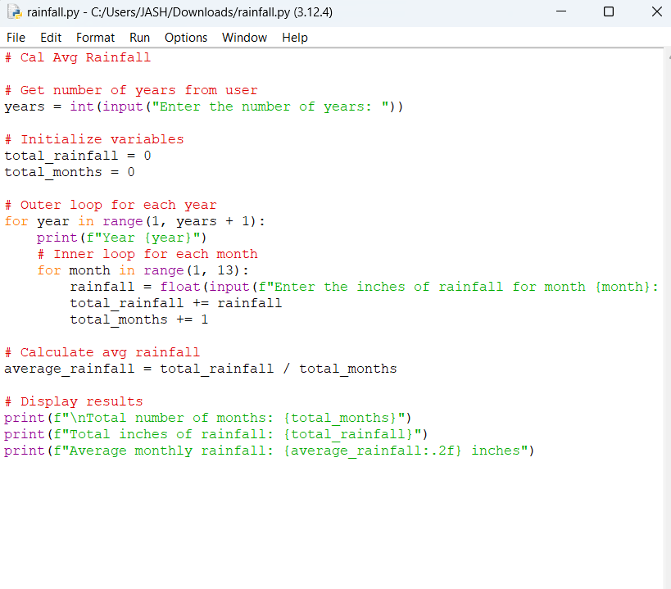

**Executed Code:**

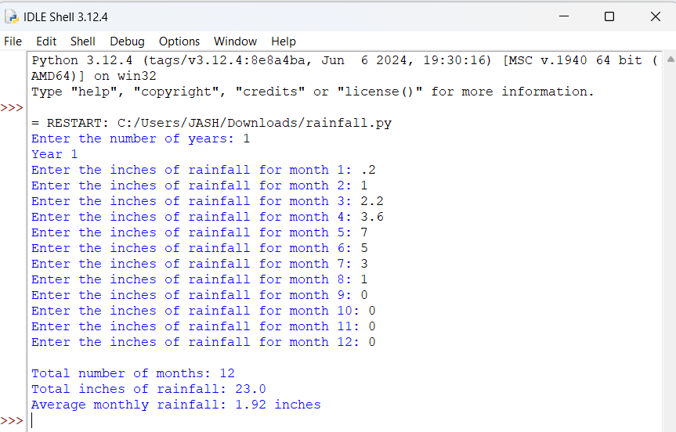

**Book Club Points Calculation**

1. Ask the user how many books they bought this month.

2. Use a series of if-else conditions to determine the points based on the number of books:

- If 0 books, award 0 points.

- If 2 books, award 5 points.

- If 4 books, award 15 points.

- If 6 books, award 30 points.

- If 8 or more books, award 60 points.

3. Display total points awarded based on the number of books bought.

**Code:**

**Book Club Points Calculation**

# Get number of books purch from the user

books_purchased = int(input("How many books bought this month? "))

# Calc points based on the number of books purchased

if books_purchased == 0:

points = 0

elif books_purchased == 2:

points = 5

elif books_purchased == 4:

points = 15

elif books_purchased == 6:

points = 30

elif books_purchased >= 8:

points = 60

else:

points = 0

# Display points awarded

print(f"Points awarded: {points}")

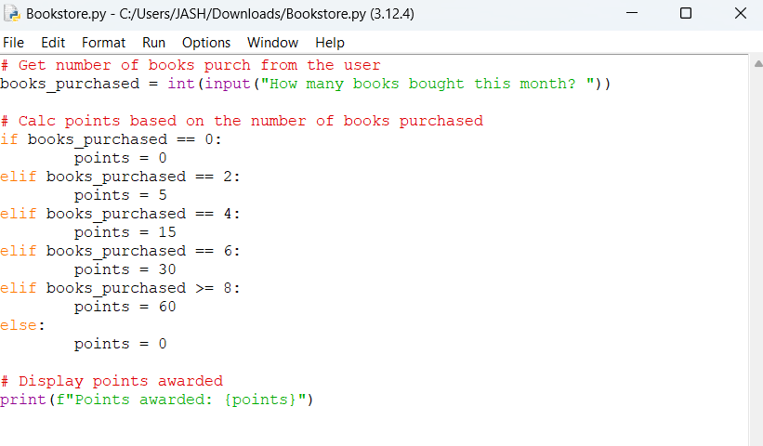

**Executed Code:**

